**Menus:**

**Main Menu:**



Main menu consists of five buttons:

* **Play**: Opens the player select menu.
* **Settings**: User can change sound settings from this menu.
* **Credits**: Shows the names of the people who worked on the game.
* **How to Play**: Shows key bindings.
* **Exit**: Exits the game.

**Player Select Menu:**

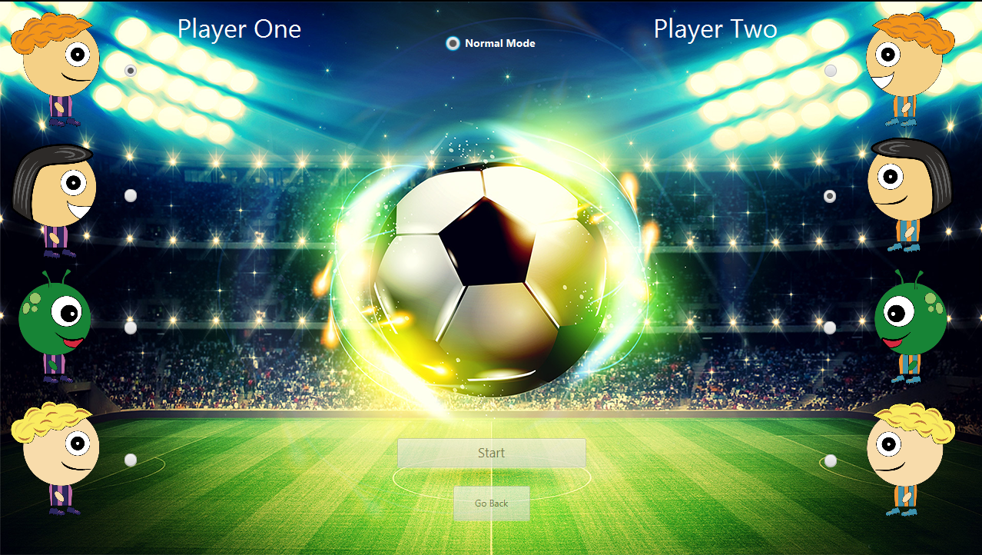

Player select menu consists of two buttons and three radio buttons group.

* **Player One Select:** First user can select his character from these 4 different avatars. Default is the first avatar. This player’s goal will be on the left side.
* **Player Two Select:** Second user can select his character from these 4 different avatars. Default is the second avatar. This player’s goal will be on the right side.
* **Game Mode Select:** Players can select different game modes from here. Default is “Normal”. Note: current implementation of the game only supports “Normal Mode”.
* **Start:** Starts the game with the selected avatars and mode.
* **Go Back:** Returns to the previous menu (main menu).

**Settings Menu:**



Settings menu consist of one checkbox and one button:

* **Sound:** User can turn on/off the sound of the game. On by default.
* **Go Back:** Returns to the previous menu (main menu).

**Credits Menu:**

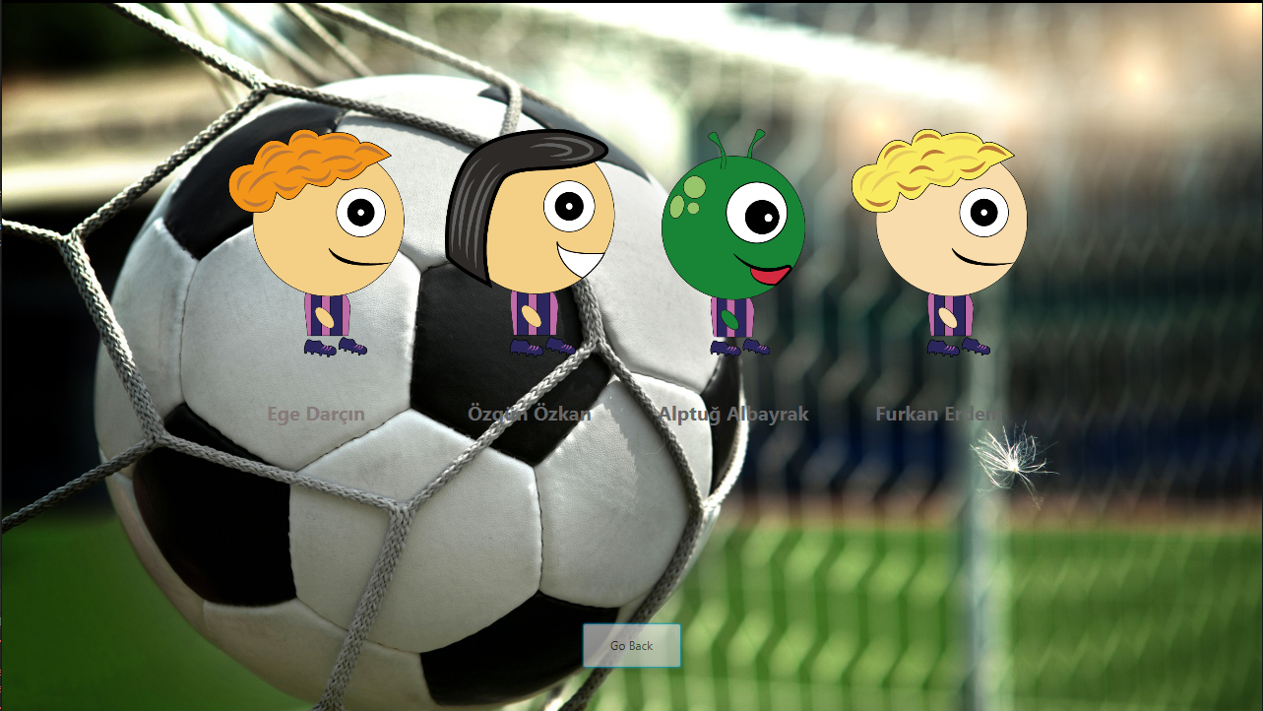

Credits menu consist of group member names and a “Go Back” button to return to the previous menu.

**How to Play Menu:**

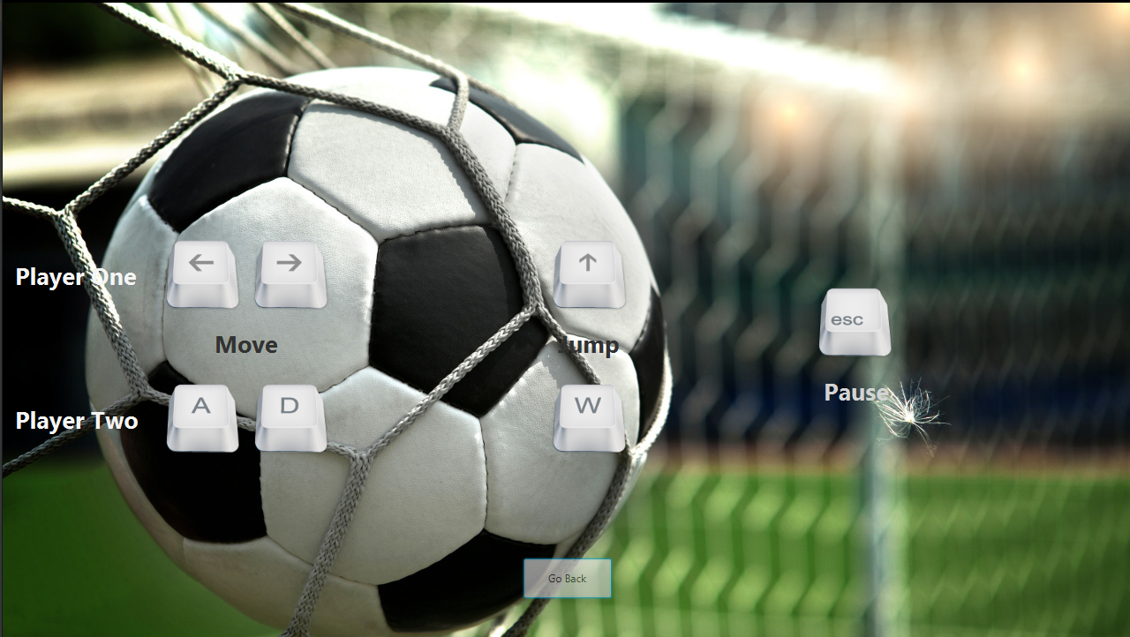

How to play menu consist of key bindings of the game and a “Go Back” button to return to the previous menu.